Overview:

* Progress towards goals:
  + Goal per game: Goal 1.4 | Actual 1.33
  + Goals Conceded per game: Goal 1 | Actual 1.78
  + Shots: Goal 12 | Actual 8.89
  + Forward pass accuracy: Goal 72% | Actual 68%
  + Crossing Accuracy: Goal 39% | Actual 37.1%
  + Defensive Duels Accuracy: Goal 71% | Actual 61.5%
  + Throw in Accuracy: Goal 89% | Actual 87.1%
* Crossing/Cutback accuracy is lacking on right side (27%)
* Right flank tends to be more dangerous when crosses/passes are successful but the left flank has more successful but less dangerous passes/crosses on average.
* Check out player passes for players contributing to dangerous passes
* 57% of opponent’s shots are coming off turnovers/2nd balls while only 25% are off set pieces
* 42% of goals are originating from set pieces
* We need to reduce turnovers in the midfield to reduce opponent’s number of chances
* Low shots on target per average given the number of dangerous balls we have
* The games we played well this season we had a high number of offensive duels and shots on target. Additionally forward and crossing accuracy
* Attack the sides of zone 14 highest rate of success
* Defend the corners of our box better
* Jonah to improve offensive and defensive duels

# Passing

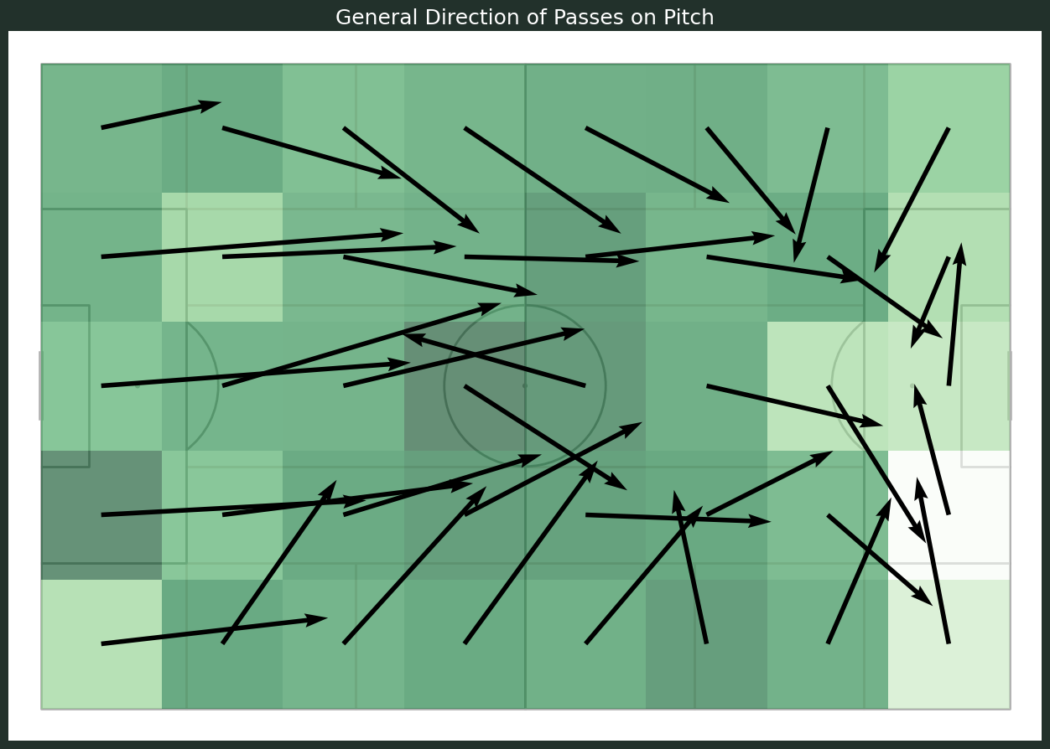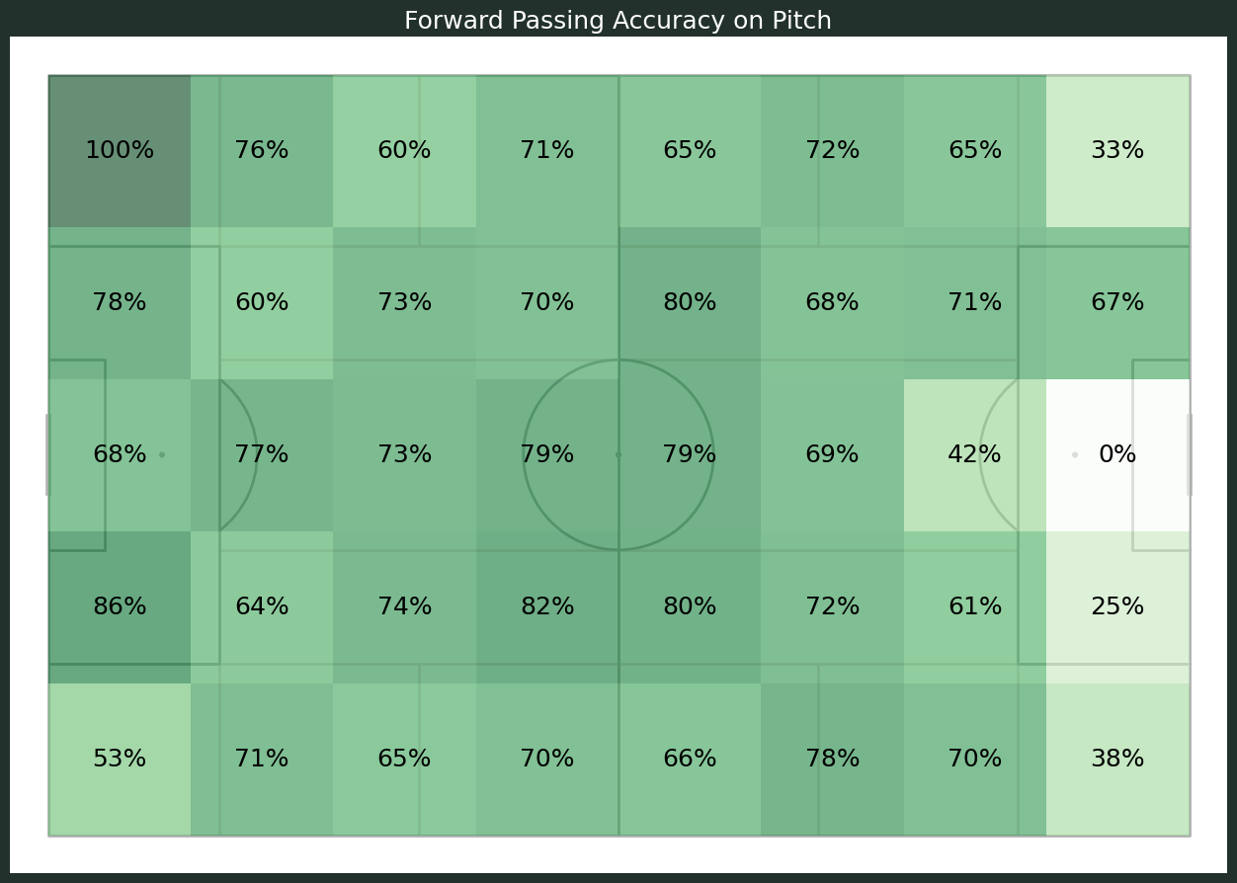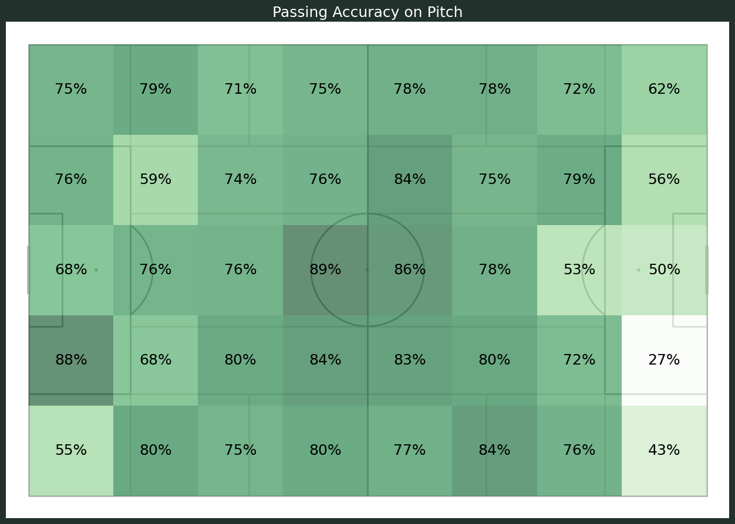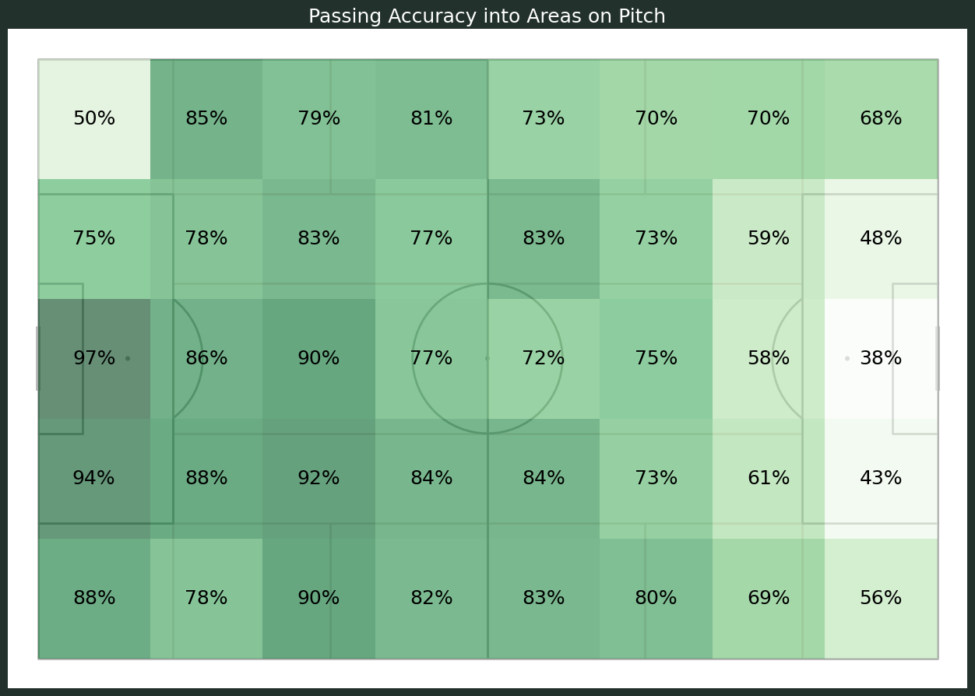

Passes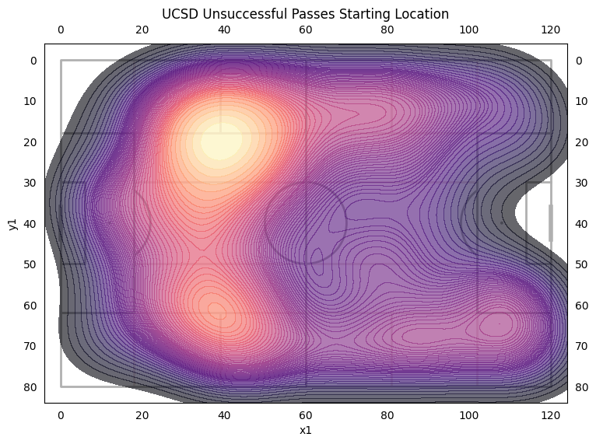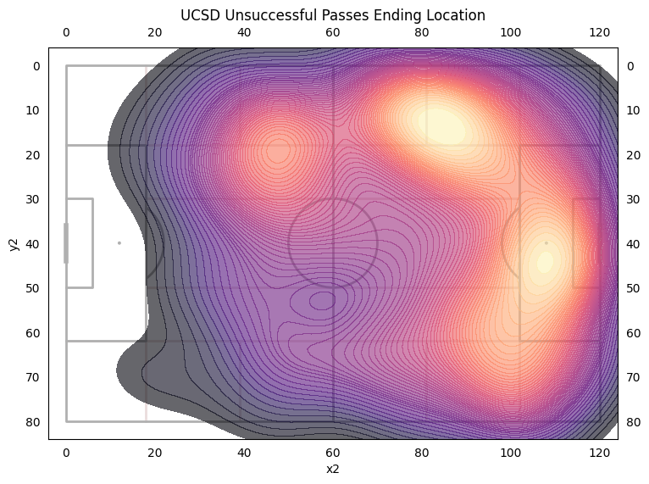

A lot of key passes (A pass that immediately creates a clear goal scoring opportunity for a teammate) from the right side but most deep completed passes are on the left. 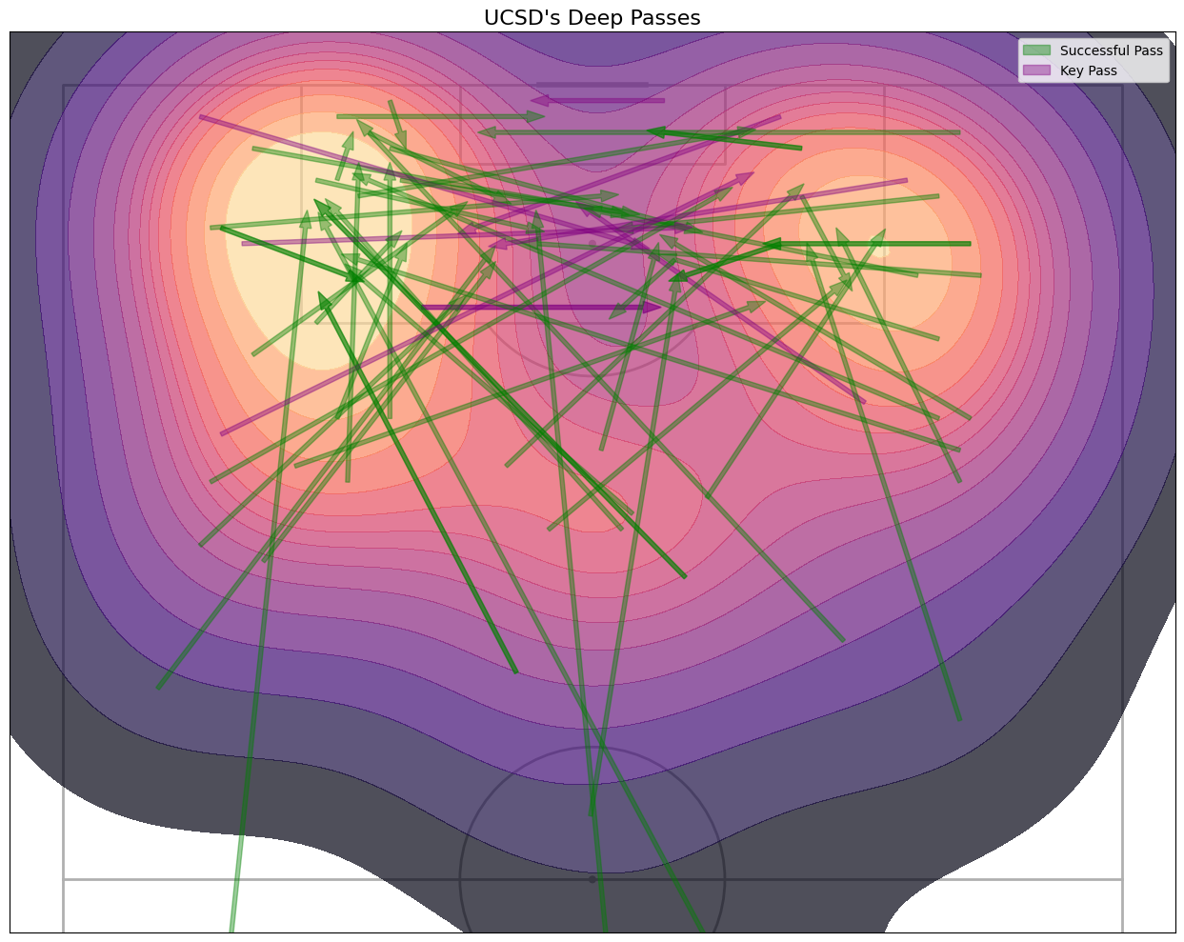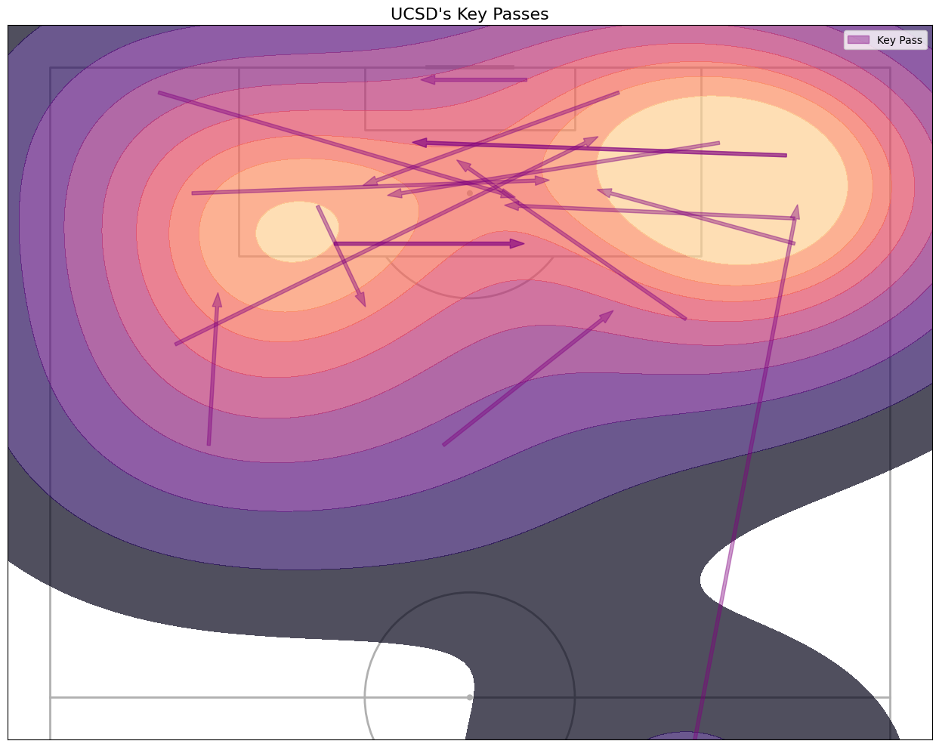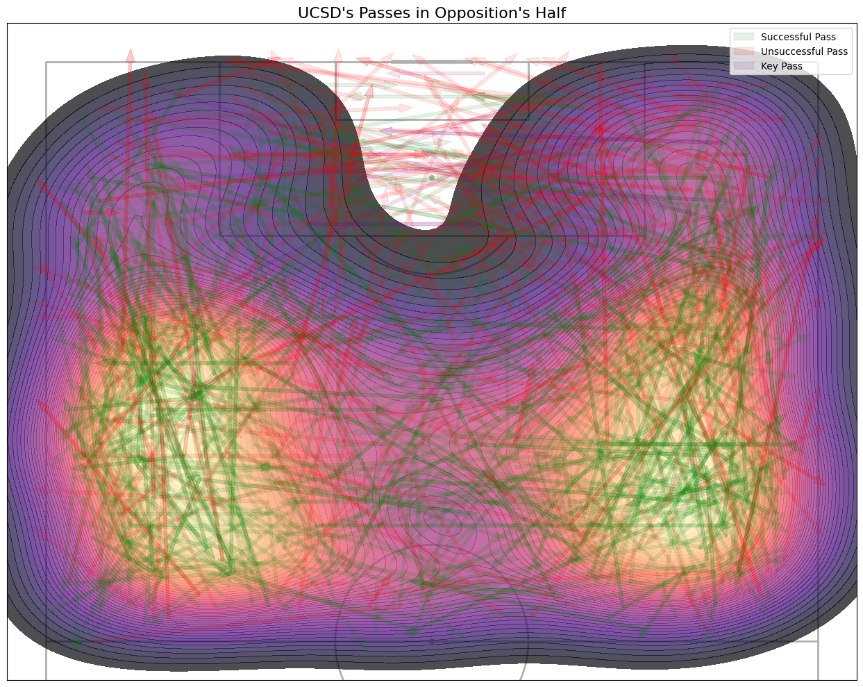

Maybe suggesting left side attacks are not posing as much of a threat or are easily thwarted compared to the right side when the passes are successful.

## Player Passes

Key Passes Deep Passes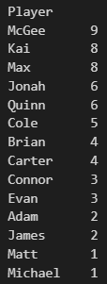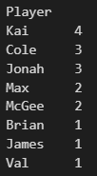

# Chances Conceded

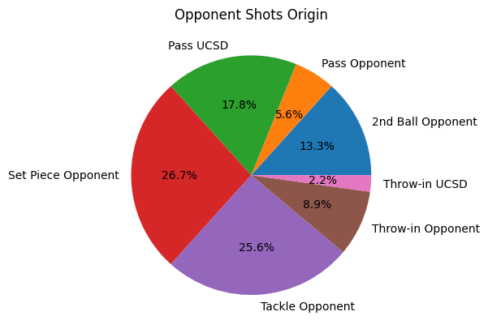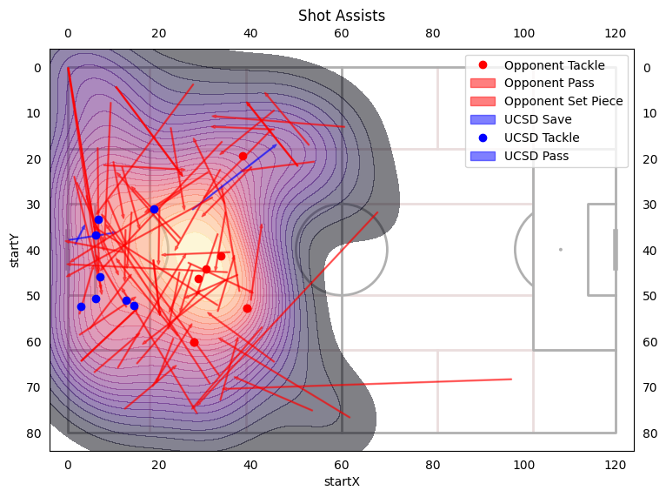

Origins

Goals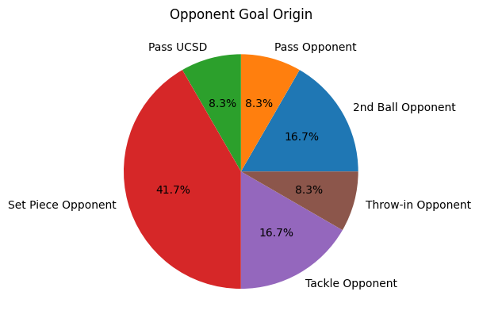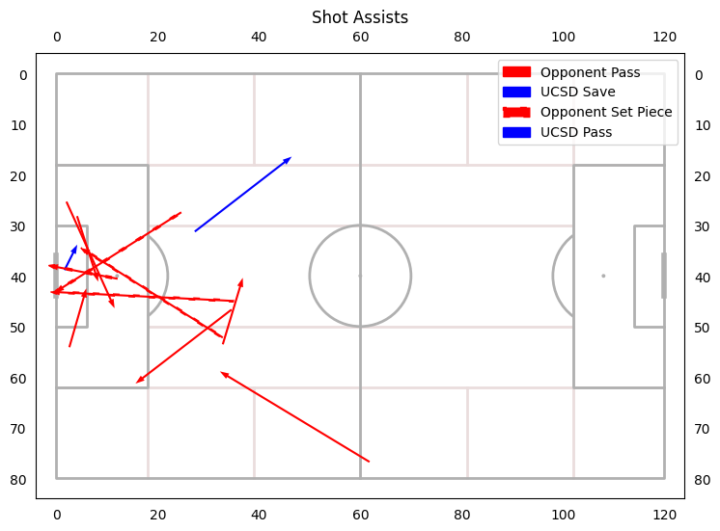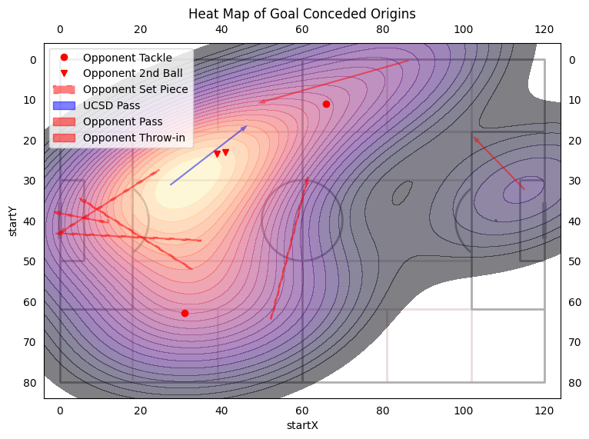

# League Comparison

To Improve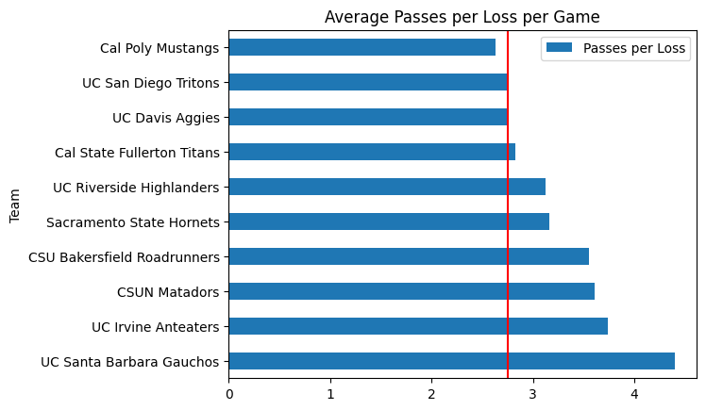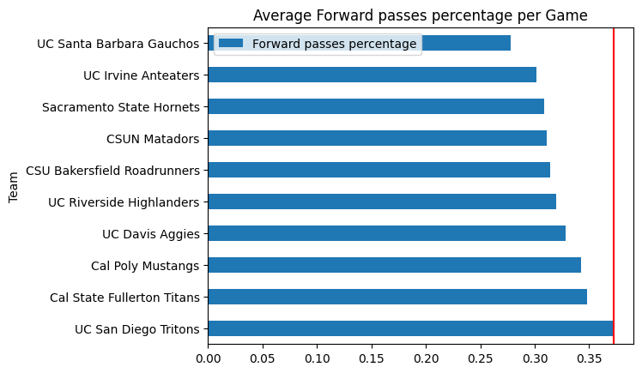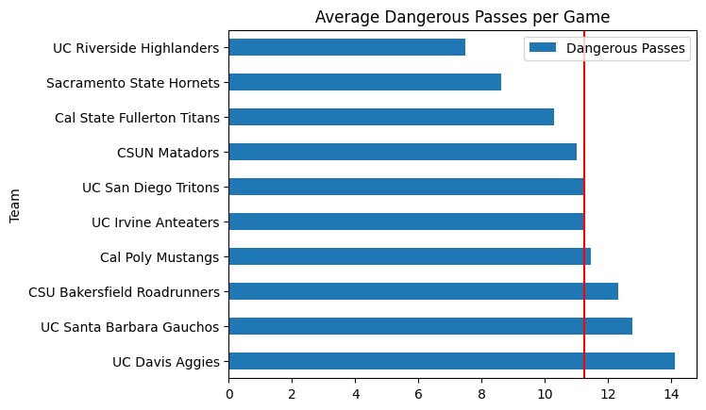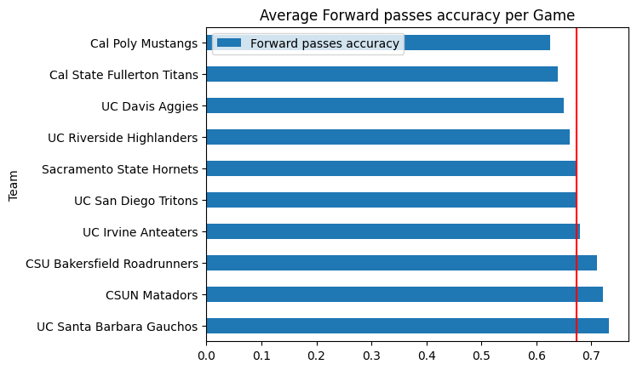

* Very low shots on target per game
* Low pass accuracy in league
* High percentage of our passes are forward while forward pass accuracy is average
* Average dangerous passes per game
* Very low passes per loss

# By Game

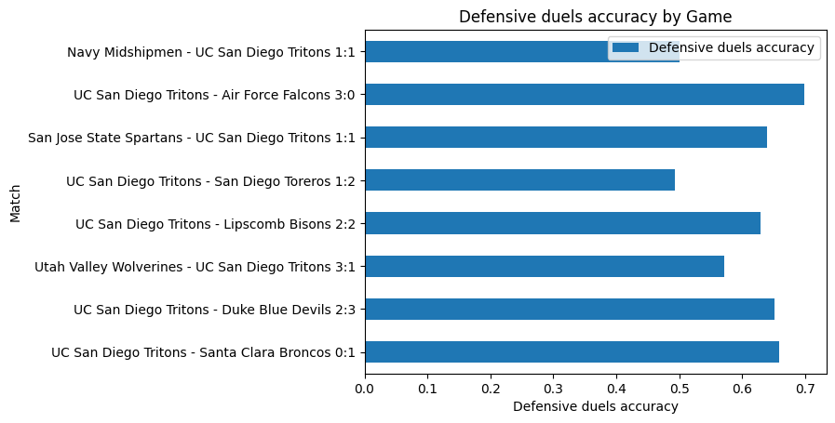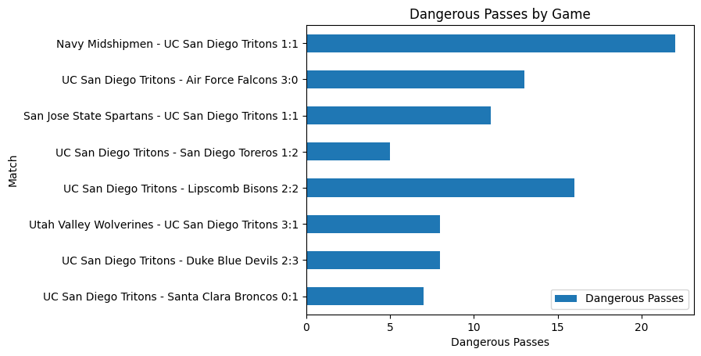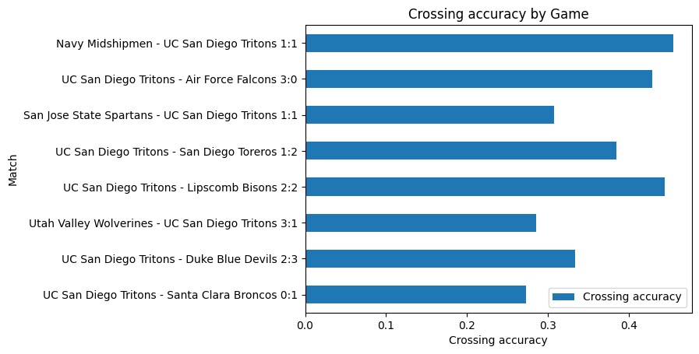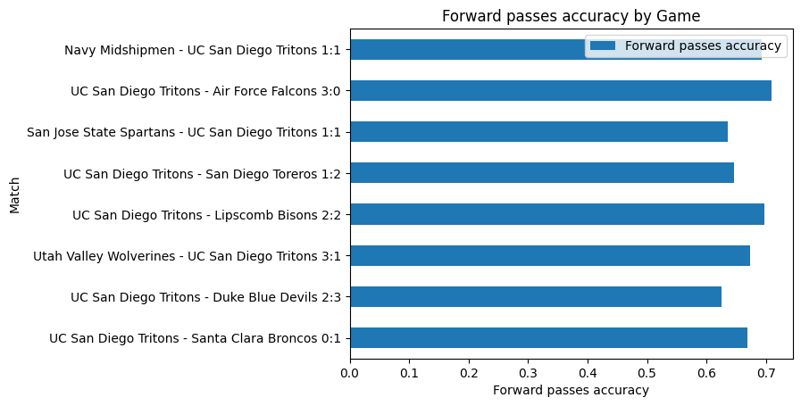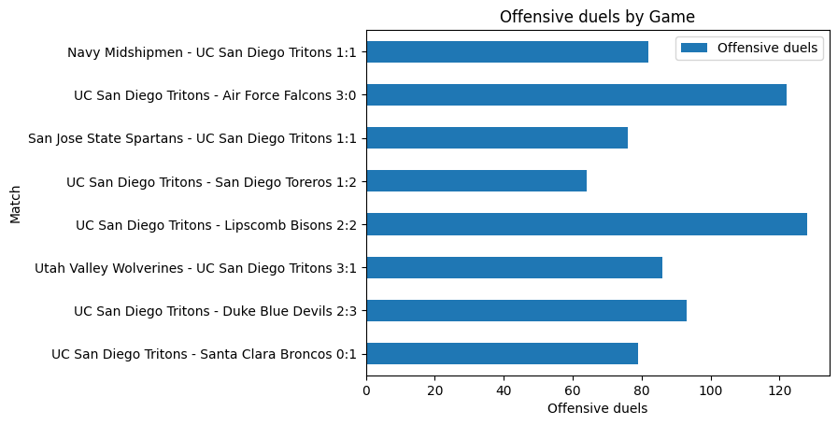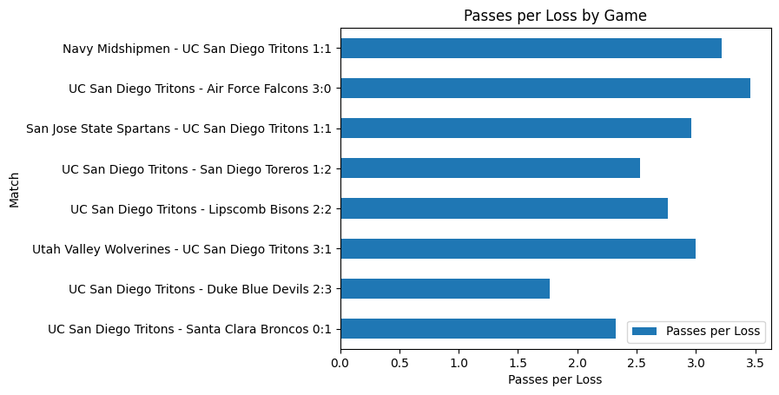

Game we played well we had:

* High touches in penalty area
* High shots on target
* Higher forward pass accuracy
* More offensive duels
* More dangerous passes
* Higher passes per loss
* High crossing accuracy

Observe difference between Navy and other successful games for us (Air Force, Lipscomb, SJS)

# Offensive Duels

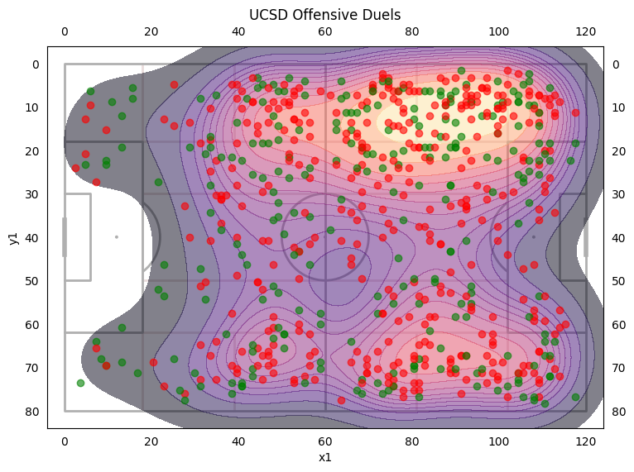

* 58.4% of offensive duels are on left while 41.6% are on right
* Overall accuracies are about the same
* Highest accuracy in the attacking third is just to the sides of zone 14
* Low winning rate in the central zone of opponents half
* Highest winning attacking players:
  + McGee (58%), Quinn (53.6%)
* Lowest winning attacking players:
  + Brian (23%), Max (24.7%), Ryan (30.7%), Val (32.2%), Kai (33%)
* Jonah is only at 34.7%

# Defensive duels

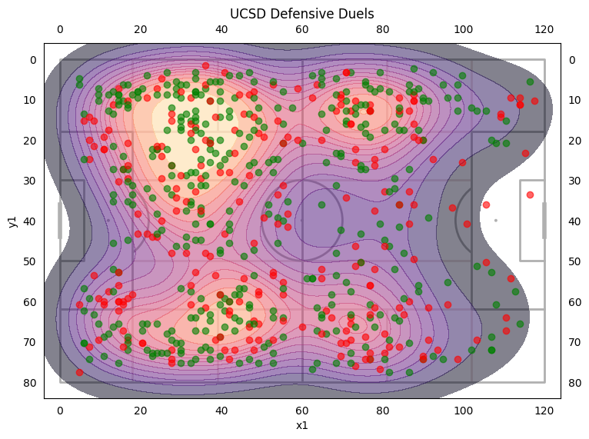

* First note the 0% there is only a couple duels there
* We need to increase our duel win rate at the corners of our box.
* High win rates in the central midfield and out wide in our defensive third.
* Highest winning defensive players:
  + Keenai (90%), Carter (75%), Matt (75%), Evan (66%), Quinn (65.6%)
* Lowest winning defensive players:
  + Woody (59.2%), Adam (60.7%), Jonah (60.8%)